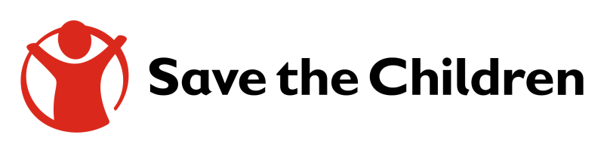

TOR – Digital Campaign Services

Guidelines:
SCI is seeking the services of a media production company or an individual to supply digital campaign content. The produced materials will be used for Save the Children vaccination campaign that will last for at least 6 months.

All products must conform to Save the Children branding standard; revisions of the same should be done as suggested by Save the Children before reprographics commences.

Scope of Work - Project Process:
The supplier will be expected to deliver any of the following as required during the duration of the
contract:
- Provide content for Save the Children digital media campaign (Facebook-Twitter-WhatsApp – Web..etc)
- The supplier shall use their own professional editing software;
- Edit the footage in line with the script agreed and approved by the SCI focal person.
- Produced materials should be provided with both English and Arabic according to the need.
- The final product should be convert it in formats for use on social media (facebook, whatsapp, twitter)
- Final products can be subject to size modification for different uses.
- Include appropriate SCI branding as per the Save the Children instructions and SCI brand guidelines.

DELIVERABLES
Key deliverables are quality products as per the guidelines/budget:

- Provide Creative/strategic concept to be approved by Save the Children prior to the initiation of any design/art work related to the campaign.
- Production of Digital Content: (1) art/design work, (2) copy writing. All produced materials must be of the highest quality to adequately represent the organization.

The deliverables will involve, but will not be limited to:

- Suggested number of art work/design needed for the campaign after agreement with Save the Children focal points.
- Development of the detailed copy writing for the campaign to be agreed on with Save the Children focal point;
- All content should take into account local culture and language.
- Delivery of digital content shall be in instalment and will start on no 16 September.

TRAVEL AND ACCOMODATION
  - There is no travel needed for this campaign.
SPECIAL TERMS AND CONDITIONS
- All work meets the highest professional standards.
- Save the Children’s Standard terms and conditions for procurement of services shall apply to contract entered into with you.
- Final products can be subject to size modification for different uses until the end of the project period.
- The quotation must include a declaration by yourself to the effect that: I, ____________________________(name), hereby certify that this quotation is a bona fide offer, intended to be the fairest, and that I have not fixed or adjusted the amount of the offer in accordance with any agreement or arrangement with any other person.
- Save the Children reserves the right to accept or reject any quotations in whole or in part and is not bound to give reasons for its decision.

Mode of submission: Quotations to be submitted via email to: omer.sharfy@savethechildren.org

Final content to be signed-off by Advocacy, Communications Campaigns and Media team.

